**VMware Horizon Monitoring Configuration Guide**

This article was updated to support v12.0 and newer of Goliath Performance Monitor.

**Prerequisites**

* Versions 6.0 to 8 2209 supported
  + Windows 8-10 (Desktop), 2012 R2 – 2022 (Server)
* Service Account with the following privileges:
  + Read-Only Admin within the Horizon Admin Console
  + Windows Administrator Rights on the Connection Server
    - requires permission to run a windows service
* PowerShell v3.0 or newer required
* Full Microsoft SQL suggested for full implementations of Goliath Performance Monitor
* Support for real-time process metrics can be resource intensive requiring us to determine viability that we would test in the implementation.

**Configure Monitoring**

These below steps will take you through the configuration process to begin monitoring your VMware Horizon environment(s). **Please note, these instructions are dependent on the** [**VMware Hypervisor monitoring**](https://support.goliathtechnologies.com/hc/en-us/articles/360024629034) **being completed.** **If this has not been done, please do so before proceeding.**

1. Navigate to the **Configure - Inventory page**
2. Click the **Manage Agents** button
3. Select the applicable VMware Horizon VDI, RDSH servers, and the connection servers in which you’d like to install the agent on.
4. Once selected, click the **Deployment Settings** button and enter administrative credentials (domain\user) in order to access the server to install the agent. Click **Ok** once completed.
   1. 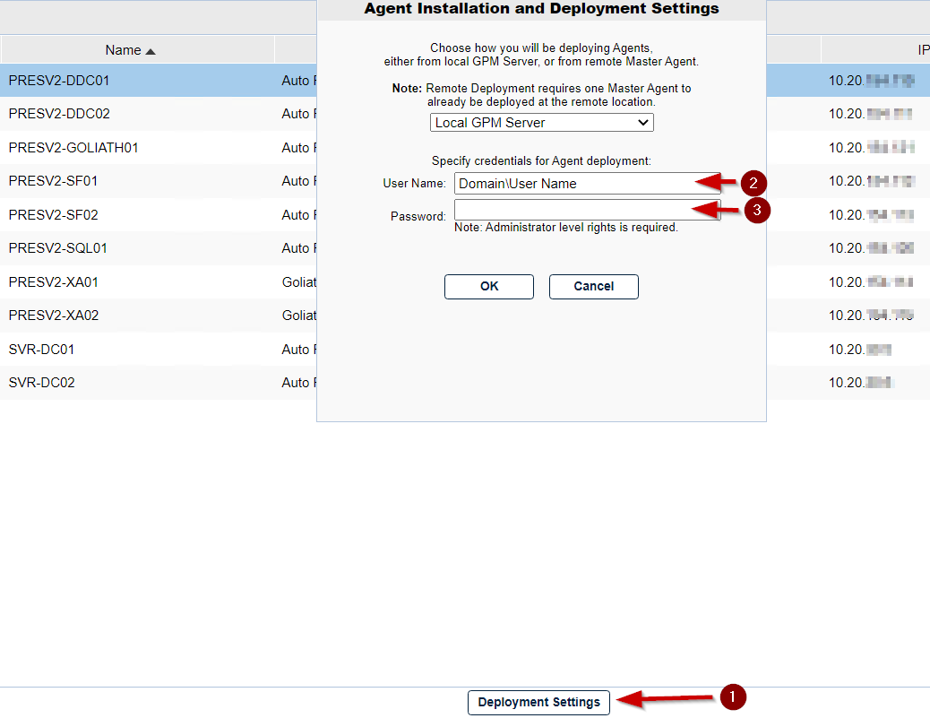
5. Click the **Install/Update Agents** button.
   1. Depending on the number of agents that are being installed or updated, the process may take about 2-10 minutes to complete. You will be prompted when the installation/update is complete.
6. Once the installation is complete, click the **Close** button to return to the Inventory page.
   1. Here, you can confirm the agents are connecting in by confirming that there is a green box in the **Agt** column for that machine. Please note, you may need to refresh the screen after a few minutes in order to see page updates.
   2. 
7. Once all of the agents are connected, select one of the VMware Horizon Connection Server and click **Edit**
8. A new pane will appear, there will be a section labeled **VMware Horizon View Monitoring** in this section please do the following:
   1. In the **User Name** and **Password** fields, please enter the credentials for the account that is a Windows Admin on the Connection Server as well as a Read-Only Admin for VMware Horizon in the format of **domain\user**
   2. Check the box for **Enable Application/Desktop and VDI Monitoring**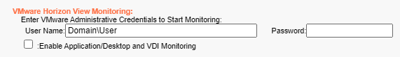
9. Once all information is filled in, click the **Save** button to complete the configuration
10. Now that the authentication information is saved, you’ll need to update the agent on the connection server in order for the API Modules to be installed
    1. Click the **Manage Agents** button
    2. Select the Horizon Connection Servers in which you enabled the integration on in steps 7-9
    3. Click the **Install/Update Agents** button
    4. The agent update process may take a dew mins to complete. You will be prompted when the installation/update is complete.
    5. Once the installation is complete, click the **Close** button to return to the Inventory page.
11. Once the new agent is deployed to the Connection Server, the API Modules will begin to enable Horizon Monitoring
    1. It may take about 5 minutes or so before the data will appear.

**Post Configuration: What’s Next?**

Now that VMware Horizon monitoring has been enabled in Goliath Performance Monitor, to start viewing session data go to the **Views - VMware Horizon** page of the technology.